PROJECT REPORT
REAL ESTATE INVESTMENT ADVISOR
Predicting Property Profitability & Future Value
A project report submitted in partial fulfillment of the requirements for
AIML COURSE
LABMENTIX
Submitted by:
ANUSHKA ROY
Under the guidance of:
VIPUL SONAWANE
Academic Session: [2026–2027]

ACKNOWLEDGEMENT
I would like to express my sincere gratitude to Mr. Vipul Sonawane, my project guide, for his valuable guidance, thoughtful feedback, and continued encouragement throughout this project. His support helped me strengthen my understanding of data analysis and machine learning and bring the project to completion.
I am grateful to Labmentix for providing the opportunity to undertake this project and for the learning environment and resources that supported my work. I also acknowledge the providers of the housing dataset and the developers of the tools and technologies used in the project.
Finally, I extend my heartfelt thanks to my family and everyone who encouraged and supported me during this work.

TABLE OF CONTENTS
SERIAL NO. | TOPIC | PAGE NUMBER
1. | Abstract and Keywords | 4
2. | Introduction | 5
3. | Problem Statement | 5
4. | Aim and Objectives | 6
5. | Scope of the Project | 6
6. | Tools and Technologies Used | 7-9
7. | Standard Python Libraries and Modules | 9
8. | Methodology | 10-12
9. | Project link and resources | 13
10. | Dataset description | 13-14
11. | Data preprocessing and feature engineering | 15-16
12. | Exploratory Data Analysis | 17-35
13. | Results | 35-39
14. | Discussions | 39-40
15. | Limitations | 40
16. | Conclusion | 41
17. | Future Study | 41

ABSTRACT
This project presents a Real Estate Investment Advisor that uses exploratory data analysis and machine learning to examine property listings and provide illustrative investment estimates. The analysis used a dataset of 250,000 property records with 23 features, including location, property type, size, price, age, amenities, and accessibility. Data checks identified no missing values or exact duplicate rows. However, 116,304 records had a floor number greater than the building’s total floors, and the price and size distributions appeared unusually uniform. The correlation between property size and price was approximately −0.003, indicating almost no linear relationship in this dataset.
The project developed classification models to predict whether a property meets a simplified “Good Investment” rule based on price per square foot. A Logistic Regression baseline achieved 71.2% accuracy; XGBoost was also trained for classification, and its feature importance is displayed in the app. A regression model estimates a five-year price using an assumed annual increase of 8%. Its MAE of 0, RMSE of 0, and R² of 1.00 reflect that the target was generated from this same formula, rather than evidence of reliable real-world forecasting. MLflow was used to track model experiments and metrics.
The Streamlit application brings together property inputs, investment classification, the illustrative five-year price scenario, XGBoost feature importance, and city comparison charts. Because the data and target definitions have limitations, the outputs are intended for project demonstration and should not be treated as validated market or financial advice.
Keywords: Real Estate Analytics, Exploratory Data Analysis, Python, Pandas, Classification, Regression, XGBoost, Scikit-learn, Streamlit, MLflow, Feature Importance, Data Visualization.

INTRODUCTION
Real estate investment decisions depend on many factors, including property price, size, location, property type, and nearby amenities. Comparing these factors across many listings can be difficult. This project explores a dataset of Indian property listings and develops a simple application to help users examine property information and view model-generated estimates.
The project uses exploratory data analysis to summarize patterns in the dataset, classification to identify properties that meet a project-defined investment rule, and regression to show an illustrative five-year price estimate. A Streamlit application presents the inputs, estimates, and visualizations in one interface. MLflow is used to track model experiments.
The results are limited by the dataset and the project’s assumptions. The “Good Investment” label is a simplified price-per-square-foot rule, and the five-year estimate assumes an 8% annual increase. These results are for educational demonstration and are not verified investment or market advice.
PROBLEM STATEMENT
Property investors often need to compare listings using several factors, such as price, size, location, property type, age, and amenities. Reviewing these details manually can make it difficult to identify patterns or compare properties consistently.
This project addresses that challenge by analyzing the provided Indian housing dataset and building a simple application that presents two model-based outputs: whether a property meets a project-defined “Good Investment” rule, and an illustrative estimate of its price after five years. The classification rule is based on price per square foot, while the future-price estimate assumes an 8% annual increase.
The project also includes exploratory charts and XGBoost feature-importance visualization to help users inspect patterns in the data. Since the dataset contains quality concerns and the targets rely on simplifying assumptions, the outputs are intended for educational demonstration, not as verified financial advice or reliable market forecasts.

AIMS AND OBJECTIVES
Aim
To analyze the provided Indian housing dataset and build an interactive application that demonstrates property investment classification and an illustrative five-year price estimate.
Objectives
- Examine the dataset’s structure, quality, and key variables.
- Explore property prices, sizes, locations, property types, amenities, and other features using descriptive statistics and visualizations.
- Identify data quality issues and document how they affect the analysis.
- Prepare the data for machine learning by applying suitable feature engineering, encoding, and scaling.
- Train and evaluate classification models, including XGBoost, to predict the project-defined “Good Investment” label.
- Train and evaluate a regression model for the project’s assumed five-year price target.
- Track model experiments and metrics using MLflow.
- Build and deploy a Streamlit application to display property estimates and visualizations.
- Explain the project’s assumptions and limitations so users do not interpret its estimates as verified financial advice.
SCOPE OF THE PROJECT
This project focuses on analyzing the provided Indian housing dataset and demonstrating a machine learning workflow for real estate listings. It includes data inspection and preparation, exploratory analysis of property and location features, and visualizations of selected patterns.
The project trains classification models, including XGBoost, to predict a simplified “Good Investment” label based on the project’s price-per-square-foot rule. It also uses regression to estimate a five-year price based on an assumed 8% annual increase. Model experiments and metrics are tracked using MLflow, and a deployed Streamlit application lets users enter property details and view estimates and charts.
The scope is limited to the dataset and assumptions used in this project. It does not verify current property listings, predict actual market movements, assess legal or financial risks, or provide personalized investment advice. Data quality issues—including inconsistent floor information and unusually uniform price and size distributions—may limit how broadly the findings can be applied.

TOOLS AND TECHNOLOGIES USED
S.No | CATEGORY | TECHNOLOGY | VERSION | PURPOSE | PROJECT USE
1. | Cloud Platform | Google Colab |  | Provides a hosted notebook environment | Ran the data processing, analysis and model code
2. | Programming language | Python | 3.13.17 | Main language for data cleaning, integration, analysis, and machine learning | Notebook code
3. | Data processing | Pandas | 2.2.3 | Reads, cleans, reshapes, and combines CSV and Excel data | Main language for data cleaning, integration, analysis, and machine learning
4. | Numerical computing | NumPy | 2.1.3 | Performs numerical and array calculations | Supports data analysis and model calculations
5. | Machine learning | Scikit-learn | 1.6.1 | Provides regression algorithms and model evaluation metrices | Linear regression, decision tree, random forest, and gradient boosting, where implemented
6. | Python data visualization library | Seaborn | 0.13.2 | Creates statistical charts and helps visualize distributions and relationships in data. | Creating statistical charts, such as box plots and correlation heatmaps.
7. | Visualization | Matplotlib | 3.10.0 | Creates charts and plots | Actual-versus-predicted graphs, trends, and 3D plots, where implemented.
8. | Model saving | Joblib | 1.6.0 | Saves and loads trained python models. | Model persistence
9. | Excel file support | Openpyxl | 3.1.5 | Let’s Pandas read excel files | Loading .xlsx datasets
10. | Notebook display | IPython | 7.34.0 | Display dataframes | Used with display() in notebook cells
11. | Python Web Framework | Streamlit | 1.66.1 | Streamlit turns the trained models into an interactive web app where users can enter property details and view predictions and charts. | In this project, Streamlit provides a web app where users enter property details and view investment predictions, five-year price estimates, and charts.
12. | MLOps | MLflow | 3.17.2 | MLflow tracks the project’s model experiments, parameters, metrics, and saved model artifacts. | MLflow’s purpose in this project is to record and compare model runs, including their parameters, evaluation metrics, and saved artifacts.
13. | Platform as a Service | Streamlit community cloud | N/A | Streamlit Community Cloud hosts the Streamlit app online so others can access it through a web link. | In this project, Streamlit Community Cloud deploys the real estate app online so users can enter property details and view its estimates and charts.
14. | Version control system | GitHub | N/A | GitHub stores and versions the project code and files, and connects the app to Streamlit Community Cloud for deployment. | In this project, GitHub stores the code, models, and supporting files, and provides the repository used to deploy the Streamlit app.
15. | Supervised machine learning algorithm | XGBoost | 3.4.1 | Classification and Regression tasks | XGBoost predicts whether a property meets the project’s “Good Investment” rule and shows which features influenced its prediction.
16. | Spreadsheet software | Microsoft Excel | 2607 Build 16.0.20228.20190 | Opens and reviews the supplied spreadsheet datasets | Inspected source workbooks
17. | Data format | CSV | No software version | Stores the input datasets and exported tables | Input files and Power BI import files
18. | Report writing | Microsoft Word | 2607 Build 16.0.20228.20190 | Prepared the written project report and documentation. | used to prepare and format the project report and documentation
19. | Document format | Word .docx | Not applicable | File format used to save Word reports; it is not a library or software version. | Word documents were used to present the project’s objectives, methodology, tools, results, and conclusions in a structured report.

STANDARD PYTHON MODULES USED IN THIS PROJECT
Handles archives, filenames, and text/date parsing
S.No | LIBRARIES AND MODULES | VERSIONS | PURPOSES
1. | Pandas(pandas) | 2.2.3 | Reads, cleans, combines, and displays CSV and Excel datasets; manages data tables and missing values.
2. | NumPy(numpy) | 2.1.3 | Performs numerical calculations; used for operations such as calculating RMSE with a square root.
3. | Matplotlib (matplotlib.pyplot) | 3.10.0 | Creates plots and graphs, including actual-versus-predicted comparisons.
4. | Scikit-learn (scikit-learn) | 1.6.1 | Provides train, test, split, RandomForestRegressor, IsolationForest, and the evaluation metrics MAE, MSE, and R². Used for splitting data, model training, anomaly detection, and evaluation.
5. | Joblib (joblib) | 1.6.0 | Saves and loads trained machine-learning models and related objects.
6. | Openpyxl (openpyxl) | 3.1.5 | Enables reading and writing .xlsx Excel workbooks through Pandas.

METHODOLOGY
DATA FLOW
EXPLORATORY DATA ANALYSIS
DATA PREPARATION
MODEL TRAINING AND EVALUATION
FEATURE AND TARGET CREATION
DATASET

MLFLOW TRACKING

STREAMLIT APPLICATION AND DEPLOYMENT

1. Data Loading and Inspection
The housing dataset was loaded into a Pandas Dataframes. Its dimensions, column names, data types, sample records, and descriptive statistics were examined to understand the available information and identify possible quality issues.
The dataset contained 250,000 records and 23 columns, covering property location, type, size, price, age, amenities, ownership, and availability.
2. Data Quality Checks and Preparation
The dataset was checked for missing values and exact duplicate records. No missing values or exact duplicates were found, so neither imputation nor duplicate removal was required.
Property age was checked using the calculation:
Age of Property = 2025 − Year Built
This calculation matched the existing Age_of_Property values. Floor records were also checked. In 116,304 rows, Floor_No was greater than Total_Floors. These records were flagged, but not corrected because the true values could not be confirmed. The floor fields were excluded from model inputs.

3. Exploratory Data Analysis
Exploratory Data Analysis was used to study property prices, sizes, locations, property types, BHK, amenities, furnishing, parking, ownership, and availability. Summary statistics and charts were used to examine distributions and relationships between variables.
The analysis found unusually uniform price and size distributions. The correlation between property size and price was approximately −0.003, indicating almost no linear relationship in this dataset. Box plots identified high outliers in recalculated price per square foot, while property size showed no outliers using the IQR method. These observations were considered when interpreting the results.
4. Feature Preparation and Target Creation
Numerical and categorical features were prepared for the machine-learning pipelines. Categorical features were encoded, and numerical features were scaled where required. The fitted preprocessing steps were included with the model pipelines so that new inputs were processed consistently.
Two project-specific targets were created:
- Investment classification: A property was labelled “Good Investment” if its calculated price per square foot was at or below the dataset median. This is a simplified project rule, not a verified measure of profitability.
- Five-year price regression: The future-price target was generated using an assumed annual increase of 8%:
Future price = Current price × (1.08)⁵
This target supports a demonstration of regression, but does not represent an observed future market price.
5. Model Training
The classification task was used to predict the project-defined “Good Investment” label. Logistic Regression was trained as a baseline, and XGBoost was trained as an additional classification model.
A regression model was trained to predict the five-year price target. The data was split into 200,000 training records and 50,000 testing records. The training data was used to fit the models, and the test data was used to evaluate their performance.
6. Model Evaluation
Classification performance was evaluated using accuracy, precision, recall, F1 score, and a confusion matrix. The Logistic Regression baseline achieved 71.2% accuracy on the test set. XGBoost was evaluated for the same classification task, with its feature importance displayed in the Streamlit application. Report its evaluation metrics using the values recorded in your notebook or MLflow runs.
Regression performance was evaluated using MAE, RMSE, and R². The model returned MAE = 0.00 lakhs, RMSE = 0.00 lakhs, and R² = 1.00. These perfect scores occurred because the target was generated from the same fixed 8% growth formula. They show that the model reproduced the formula; they do not demonstrate accurate real-world forecasting.
7. MLflow Experiment Tracking
MLflow was used to record model experiment runs, including parameters, evaluation metrics, and model artifacts. These records support reviewing and comparing the experiments performed during the project.
8. Streamlit Application and Deployment
A Streamlit application was developed to let users enter property details and view the project’s model outputs. The app displays an investment classification, an illustrative five-year price scenario, XGBoost feature importance, and a city comparison chart. The application files were stored in GitHub and the app was deployed through Streamlit Community Cloud.
9. Methodological Considerations
The analysis and models depend on the supplied dataset and the project’s target definitions. The unusual price and size distributions, inconsistent floor records, simplified investment label, and formula-generated regression target limit how the results should be interpreted. Accordingly, the app is an educational demonstration and should not be treated as financial advice or a verified property-market forecast.

PROJECT RESOURCES AND LINKS
S.No | RESOURCE | DESCRIPTION | LINK
1. | Dataset | Housing dataset used for the analysis | https://drive.google.com/file/d/1fNmKaGCQeTUmok2xVxSHOw_e05wsnCt3/view?usp=sharing
2. | GitHub  Repository | Project code, models, and supporting files | https://github.com/anushka-create03/ML-PROJECTS/tree/main
3. | a. Streamlit application  b. appp.py | Deployed interactive application.  Streamlit real estate app | https://ml-projects-ktxbkzwtj6trbp5pyyhmzf.streamlit.app/  https://drive.google.com/file/d/1aNLkIFLiG1v0t63hPLTbCdxdwpKOwMVk/view?usp=sharing
4. | Google Colab notebook | Notebook containing the analysis and model workflow | https://colab.research.google.com/drive/1zkOdu-pjqN4gF5sdpbGPmSz9TmC8npU1?usp=sharing

DATASET DESCRIPTION

S.No | COLUMN NAME | DESCRIPTION
1 | ID | Unique identifier for each property record.
2 | State | Indian state where the property is located.
3 | City | City where the property is located.
4 | Locality | Neighborhood or locality of the property.
5 | Property_Type | Type of property, such as apartment, villa, or independent house.
6 | BHK | Number of bedrooms, hall, and kitchen.
7 | Size_in_SqFt | Property area in square feet.
8 | Price_in_Lakhs | Property price in lakhs.
9 | Price_per_SqFt | Dataset’s price-per-square-foot value.
10 | Year_Built | Year the property was constructed.
11 | Furnished_Status | Furnishing level of the property.
12 | Floor_No | Floor number on which the property is located.
13 | Total_Floors | Total number of floors in the building.
14 | Age_of_Property | Property age, calculated as 2025 − Year_Built in this project.
15 | Nearby_Schools | Dataset value describing nearby schools.
16 | Nearby_Hospitals | Dataset value describing nearby hospitals.
17 | Public_Transport_Accessibility | Recorded accessibility to public transport.
18 | Parking_Space | Recorded parking availability or information.
19 | Security | Security features recorded for the property.
20 | Amenities | Amenities listed for the property.
21 | Facing | Direction the property faces, such as north or south.
22 | Owner_Type | Type of property owner or seller.
23 | Availability_Status | Property availability or construction status.

DATA PREPROCESSING AND FEATURE ENGINEERING
1. Data Loading and Inspection
The housing dataset was loaded into a Pandas Dataframes for preparation and analysis. It contained 250,000 records and 23 columns, including location, property type, size, price, age, amenities, and availability information.
The data was inspected by reviewing its column names, data types, sample records, and summary statistics. This helped identify the fields available for analysis and modelling and check whether the values appeared consistent.
2. Missing Values and Duplicate Records
The dataset was checked for missing values and exact duplicate rows. The checks found no missing values and no exact duplicate records. Therefore, no rows needed to be removed for these reasons, and no missing-value imputation was required.
This describes the checks performed on the supplied dataset; it does not mean every value was necessarily valid or realistic.
3. Consistency Checks
The property-age field was checked against the construction year. For this project, age was calculated as:
Age_of_Property = 2025 − Year_Built
The calculated age matched Age_of_Property for every record.
The floor fields revealed a data-quality issue: 116,304 records had Floor_No greater than Total_Floors. These records were identified and flagged for review. Their values were not changed, because the correct floor values could not be confirmed from the dataset. The floor fields were excluded from the model inputs to avoid relying on these inconsistent values.
4. Feature Preparation
The data included both numerical features, such as Size_in_SqFt, Price_in_Lakhs, and Nearby_Schools, and categorical features, such as City, Property_Type, and Furnished_Status.
These feature types were prepared for the machine-learning pipelines. Categorical values were encoded so the models could process them, and numerical values were scaled where required. The fitted preprocessing steps were included in the model pipelines so that prediction inputs received the same transformations as the training data.
Price per square foot was used as a comparison measure to relate property price to property size. The project also reviewed the distributions of price and size. They appeared unusually uniform, and the correlation between size and price was approximately −0.003. These patterns raised concerns about how realistically the dataset represents property markets and were considered when interpreting the findings.
5. Target Creation for Classification
A binary target named “Good Investment” was created for the classification task. Under the project’s rule, a property was labelled as a good investment when its calculated price per square foot was at or below the dataset median; otherwise, it was assigned the other class.
This rule made it possible to train and evaluate classification models, including Logistic Regression and XGBoost. However, the label represents only the project’s chosen price comparison rule. It does not account for rental income, future market changes, taxes, maintenance, financing, or other factors that determine real investment performance.
6. Target Creation for Regression
A five-year price target was created using an assumed annual increase of 8%. The calculation was:
Future price after five years = Current price × (1.08)⁵
A regression model was trained to estimate this target. Because the target was generated directly from a fixed formula, the model’s results show how accurately it reproduced that formula. They should not be interpreted as proof that property prices will increase by 8% each year.
7. Training and Testing Data
The prepared data was divided into training and testing sets. The training set contained 200,000 rows, and the testing set contained 50,000 rows. The training data was used to fit the models, while the testing data was used to evaluate their performance on records not used during training.
8. Preprocessing Limitations
The dataset checks revealed no missing values or exact duplicates, but they did reveal inconsistent floor records and unusually uniform price and size patterns. These issues could not be fully corrected using the available information. In addition, the classification and regression targets rely on simplified project assumptions. For these reasons, the model outputs are best treated as an educational demonstration rather than verified investment recommendations or market forecasts.

EXPLORATORY DATA ANALYSIS (EDA)
QUESTIONS AND ANSWERS
PRICE AND SIZE ANALYSIS
- What is the distribution of property prices?
Property prices range from ₹10 lakhs to ₹500 lakhs. The mean price is ₹254.59 lakhs, while the median is ₹253.87 lakhs. Since the mean and median are close, the average price is not being pulled strongly to one side by a large difference between these two measures.
The histogram shows that properties are spread across nearly the entire price range. The bars have similar heights, with roughly comparable numbers of properties in most price intervals. There is no clear peak around a particular price band and no strong concentration at either the lower or higher end.
This almost even distribution is unusual for real estate data, where property prices often cluster around common price ranges and can have a long upper tail. The pattern may indicate that the dataset is synthetic or generated with uniform values, so the observed distribution should be interpreted cautiously.
Interpretation: Property prices span a wide range, from ₹10 lakhs to ₹500 lakhs, but the histogram shows a nearly even number of properties across price intervals rather than clear price bands. The mean (₹254.59 lakhs) and median (₹253.87 lakhs) are close, placing the typical recorded price near the midpoint. This unusually flat pattern may reflect how the dataset was generated and may not represent a typical real estate market.
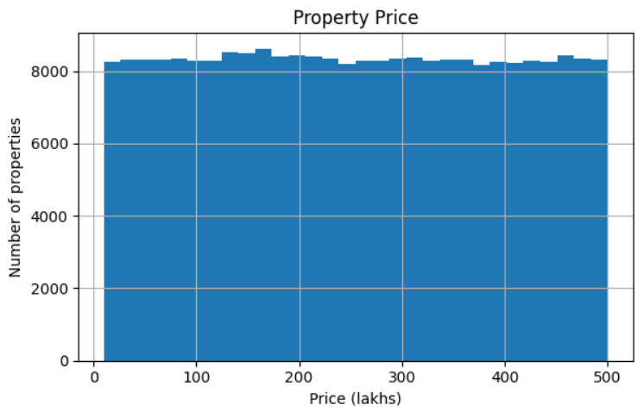
Figure 1. Distribution of property prices in lakhs.

- What is the distribution of property sizes?
Property sizes range from 500 to 5,000 sq ft. The mean size is 2,749.81 sq ft, and the median is 2,747 sq ft. Their closeness indicates that the typical recorded property is near the middle of the size range, and neither measure is strongly shifted by unusually small or large values.
The histogram shows a nearly even number of properties across the size intervals. There is no prominent peak around a particular size and no obvious concentration of listings among smaller or larger properties. This suggests the dataset represents sizes across the full range quite uniformly.
In real estate listings, property sizes often cluster around common home sizes. The unusually flat distribution here may reflect how the dataset was generated, so it should be interpreted cautiously. It also means this chart alone does not identify a most common property size.
Interpretation: The dataset includes a broad range of property sizes, but its near-uniform pattern may not reflect the distribution of sizes in a real housing market.

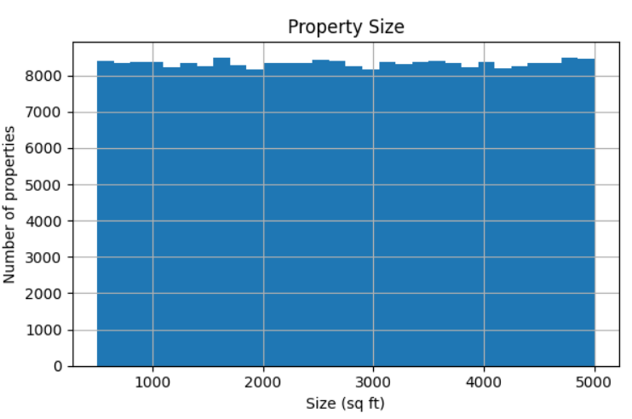
Figure 2. Distribution of property sizes in square feet.

- How does price per square ft vary by property type?
The table compares the median price per square foot for apartments, independent houses, and villas. Independent houses have the highest median at ₹9,305 per sq ft, followed by apartments at ₹9,245 per sq ft. Villas have the lowest median, at ₹9,190 per sq ft.
The difference between the highest and lowest medians is only ₹115 per sq ft, or about 1.3% of the villa median. The bars are therefore almost the same height, showing that the typical price per square foot varies very little by property type in this dataset.
Interpretation: Property type does not appear to be associated with a substantial difference in median price per square foot in these records. This finding describes the supplied dataset and does not establish that property type has little effect in the real housing market.
Property type | Median price per square ft
Villa | ₹9,190
Apartment | ₹9,245
Independent House | ₹9,305

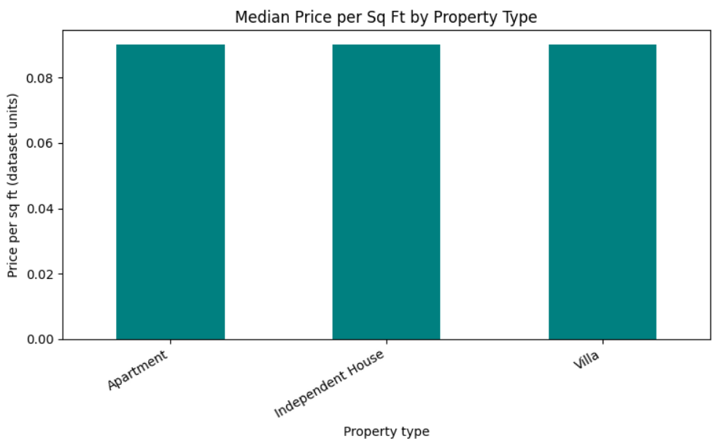
Figure 3. Median price per square foot by property type.

- Is there a relationship between property size and price?
The scatter plot compares the size of each property, measured in square feet, with its listed price in lakhs. The points are spread across the chart without forming a clear upward or downward pattern. The calculated Pearson correlation is approximately −0.003, which is extremely close to zero.
Interpretation: In this dataset, larger properties are not consistently associated with higher prices, and smaller properties are not consistently associated with lower prices. The result indicates almost no linear relationship between size and price in these records. This is unusual for property data and may reflect the dataset’s limitations; it should not be taken to mean that property size does not affect price in real markets. Correlation also measures linear association, not cause and effect.

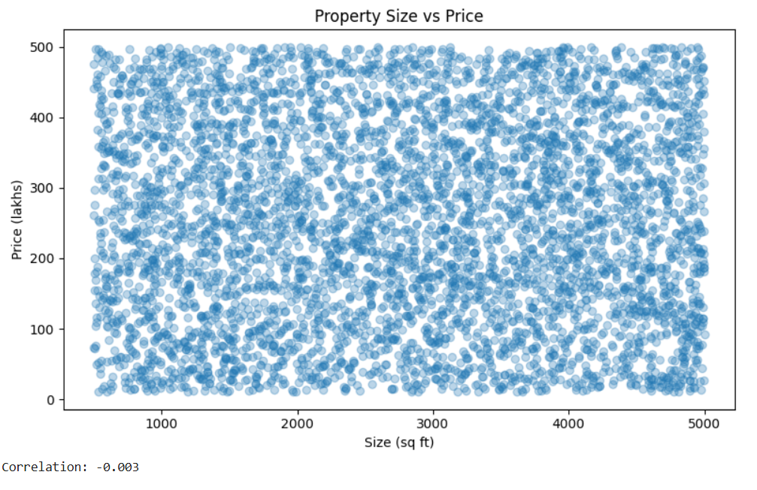
Figure 4. Scatter plot of property size versus price.

- Are there any outliers in price per sq ft or property size?
The box plots show different patterns for property size and recalculated price per square foot. Property sizes range from 500 to 5,000 square ft. Under the standard box-plot IQR rule, there are no size values beyond the whiskers. The median size is about 2,747 square ft, and the middle half of properties fall roughly between 1,623 and 3,874 square ft.
Price per square foot has a strong right-skewed pattern. Its median is approximately ₹9,245 per sq ft, while the upper whisker is around ₹32,764 per square ft. About 19,723 records lie above that whisker, and some values approach ₹100,000 per square ft. These are high-value outliers relative to the rest of the data.
Interpretation: The size values are spread across their range without IQR-defined outliers, but a substantial number of properties have unusually high price-per-square-foot ratios. These records may reflect valid high-price, small-size properties or data issues. They were flagged for review rather than removed automatically

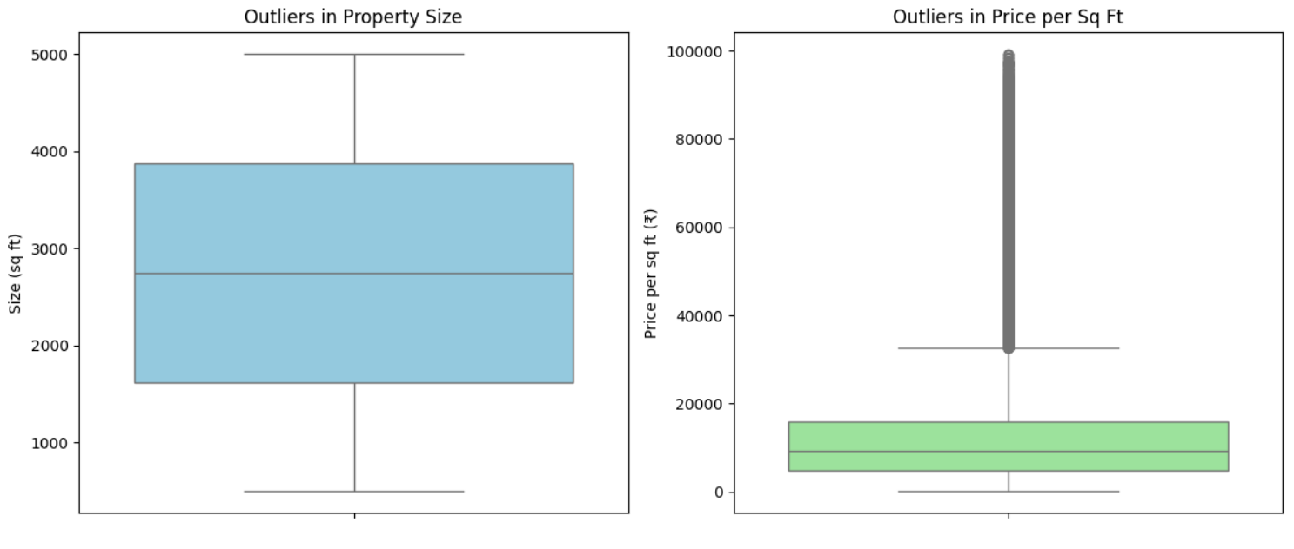
Figure 5. Box plots of property size and recalculated price per square foot.
LOCATION BASED ANALYSIS

- What is the average price per sq ft by state?
The average recalculated price per square foot ranges from approximately ₹12,931 to ₹13,252 across the states. Karnataka has the highest average, at about ₹13,252 per sq ft, followed by Andhra Pradesh at about ₹13,202 per sq ft. Punjab has the lowest average, at about ₹12,931 per sq ft.
The difference between the highest and lowest state averages is about ₹321 per sq ft. The bars are close in height, showing that average price per square foot varies only slightly among states in this dataset.
Interpretation: The chart shows little separation between state averages. This is consistent with the dataset’s generally uniform price patterns, so it may not represent the geographic price differences found in real housing markets.

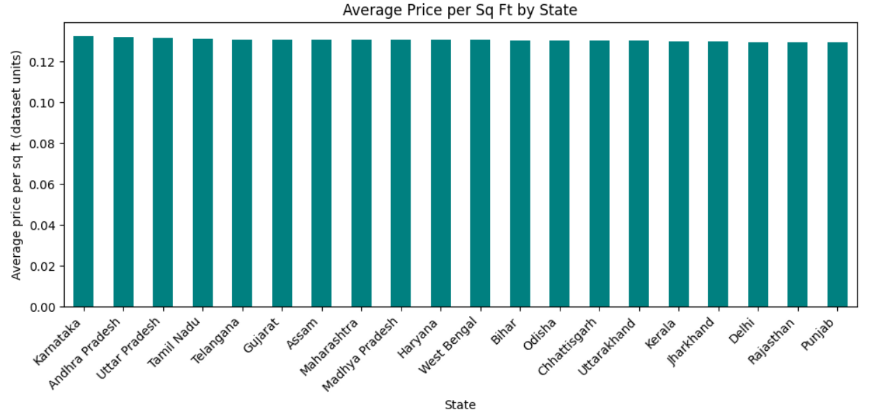
Figure 6. Average recalculated price per square foot by state.

- What is the average property price by city?
Average property prices are similar across the cities shown. Bangalore has the highest average at approximately ₹258.46 lakhs, while Cuttack has the lowest at approximately ₹250.79 lakhs. The difference is about ₹7.67 lakhs, or roughly 3% of the lowest city average.
The horizontal bar chart shows that most city averages are clustered within a narrow range. No single city stands far apart from the others in this dataset.
Interpretation: The results suggest little variation in average property price between cities in these records. The nearly uniform bars reflect the dataset’s generally even price distribution and should not be taken as evidence that real estate prices are similar across Indian cities.

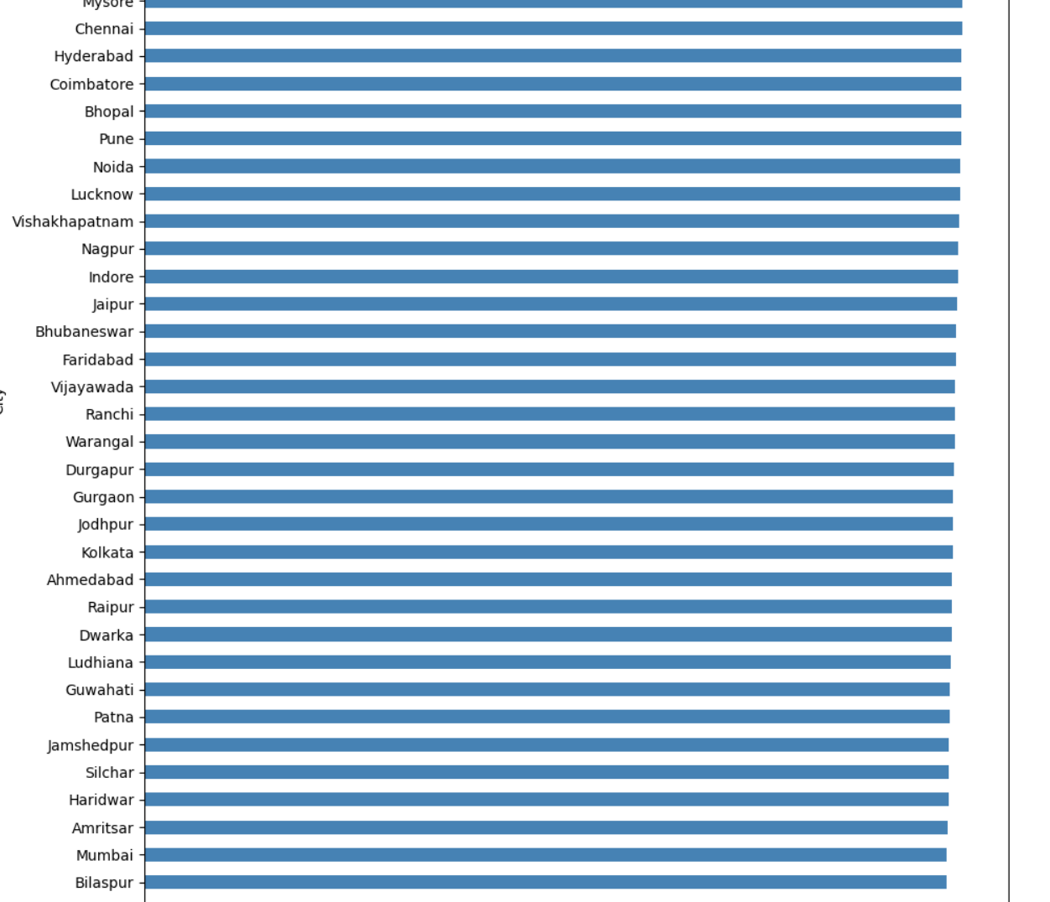
Figure 7. Average property price by city.

- What is the median age of properties by locality?
Across all localities, median property age ranges from 16 to 21 years. The median of the locality-level medians is 18 years, which is also the overall median age in the dataset.
The chart focuses on the 10 localities with the highest median property prices. Their median ages range from approximately 18 to 20 years. Locality_366 has the highest median age in this group at about 20 years; most of the other localities are around 18–19 years.
Interpretation: The selected high-price localities have similar median property ages. This comparison does not show a clear relationship between property age and high locality prices. It is a descriptive comparison, not evidence that age has no effect on property value.

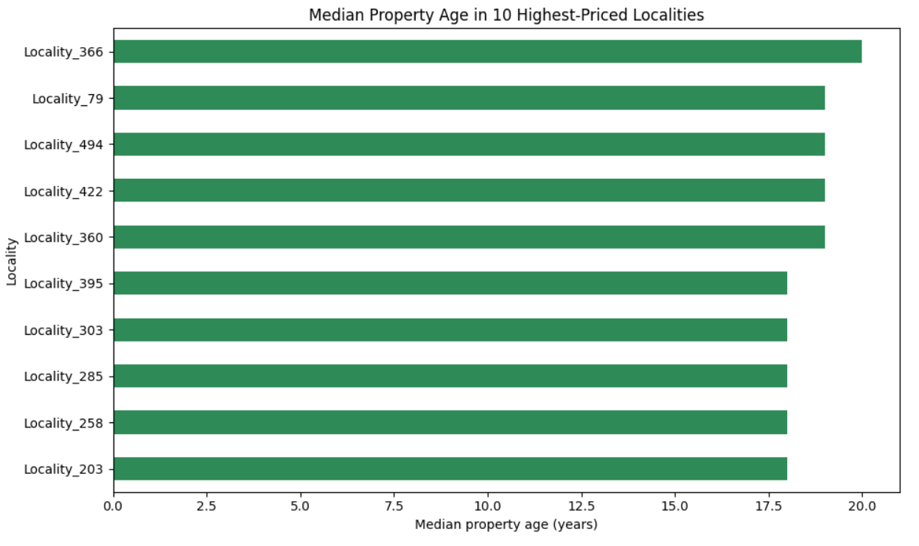
Figure 8. Median property age in the ten localities with the highest median prices.

- How is BHK distributed across cities?
The dataset contains properties with 1 to 5 BHK. Overall, the counts are very similar: 50,196 properties with 1 BHK, 49,815 with 2 BHK, 50,067 with 3 BHK, 49,788 with 4 BHK, and 50,134 with 5 BHK. Each category therefore represents about one-fifth of the full dataset.
The heatmap breaks these counts down by city. Cell colors and numbers show that individual city totals vary, but each city has records across the BHK categories. When comparing proportions within each city, each BHK category is generally close to 19–21%.
Interpretation: No single BHK category strongly dominates the dataset, either overall or within the cities. The count differences visible in the heatmap partly reflect that some cities have more property records than others. A percentage-based heatmap would make it easier to compare BHK composition between cities with different record counts.

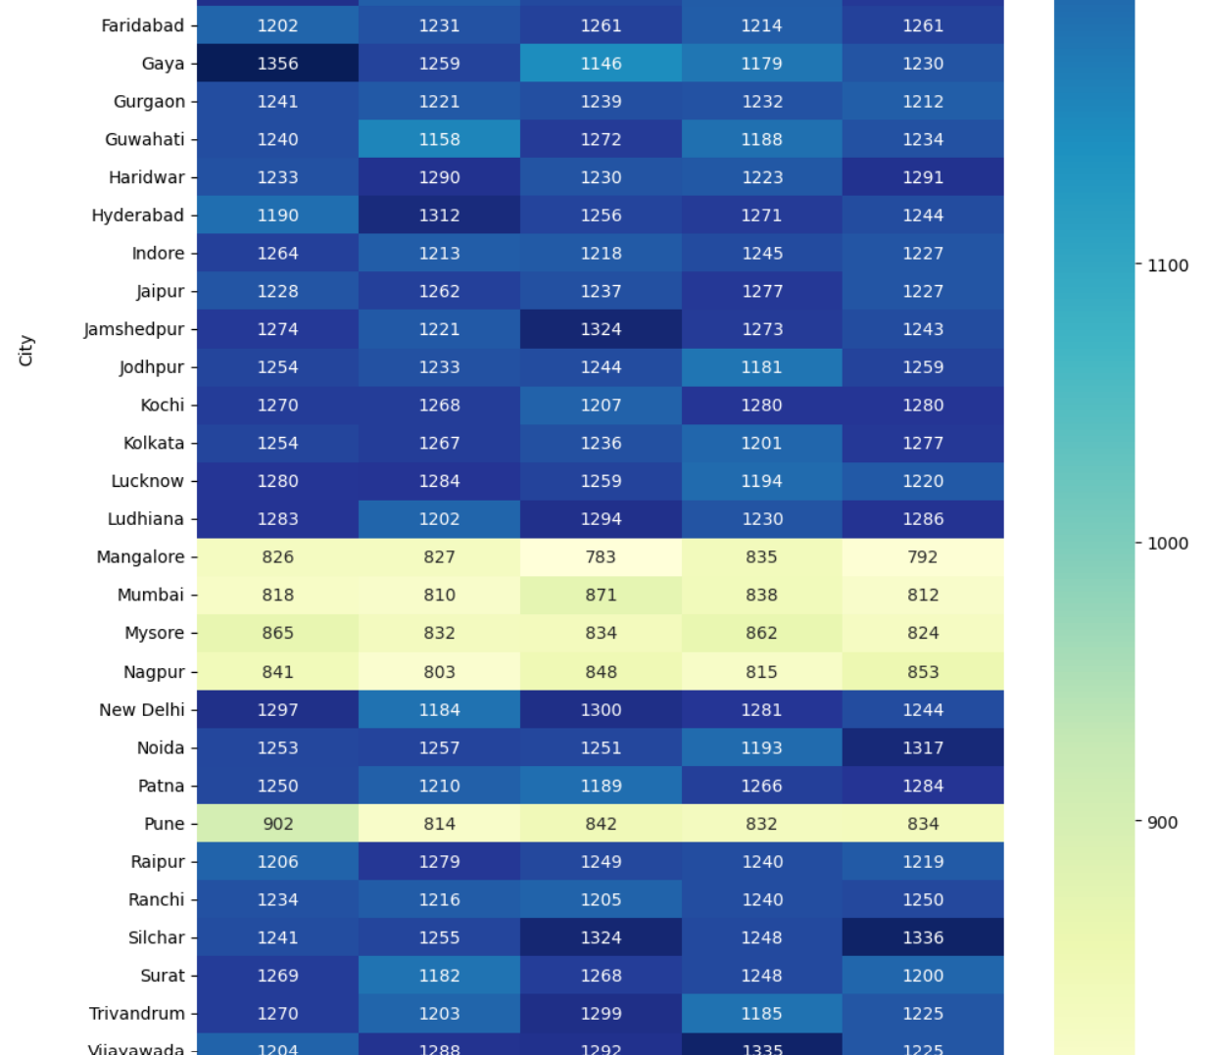
Figure 9. Number of properties by BHK category and city.

- What are the price trends for the top 5 most expensive localities?
The dataset has no date or historical price field, so it cannot show price trends over time. It can show a snapshot comparison of localities by median price. The top five by median property price are:
Locality | Median property price | Median age
Locality_395 | ₹282.68 lakhs | 18 years
Locality_366 | ₹282.33 lakhs | 20 years
Locality_303 | ₹282.27 lakhs | 18 years
Locality_79 | ₹280.76 lakhs | 19 years
Locality_203 | ₹280.32 lakhs | 18 years
These are locality comparisons from the available records, not evidence of price increases over time.
The dataset does not contain transaction dates or historical prices, so it cannot show whether prices in these localities have risen or fallen over time. Instead, the chart compares the current recorded median property prices for the five localities with the highest medians.
Locality_395 has the highest median price at ₹282.68 lakhs, followed by Locality_366 at ₹282.33 lakhs and Locality_303 at ₹282.27 lakhs. Locality_203 has the lowest median among these five, at ₹280.32 lakhs. The difference between the highest and lowest is only ₹2.36 lakhs, indicating that their median prices are very close in this dataset.
Interpretation: The chart shows a ranking of five localities by median price, not a price trend over time. The small differences suggest similar recorded median prices among these localities. The median ages range from 18 to 20 years, but this comparison does not establish that property age explains the price differences.

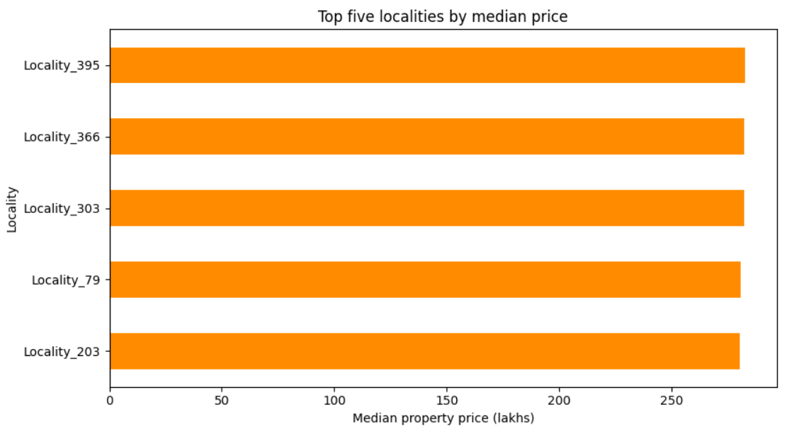
Figure 10. Top five localities by median property price.

FEATURE RELATIONSHIP AND CORRELATION

- How are numeric features correlated with each other?
The heatmap shows Pearson correlation coefficients between numeric features. Values near +1 indicate a strong positive linear association, values near −1 indicate a strong negative association, and values near 0 indicate little or no linear association. The diagonal is 1.00 because each feature is perfectly correlated with itself.
Most pairs of original numeric features have correlations close to zero. For example, Size_in_SqFt and Price_in_Lakhs have a correlation of approximately −0.003, consistent with the scatter plot’s lack of a clear linear pattern.
Some stronger correlations arise because one feature is calculated from another:
- Year_Built and Age_of_Property have a correlation of −1.00, because property age was calculated as 2025 − Year_Built.
- Price_per_SqFt is derived from price and size, so its correlations with those features are partly mathematical. The heatmap shows approximately −0.61 with size and +0.56 with price.
- Price_per_SqFt and Calculated_Price_per_SqFt have a correlation of 1.00, indicating they contain essentially the same relationship in this dataset.
Interpretation: The heatmap suggests that most numeric inputs do not have strong pairwise linear relationships. The high correlations between calculated fields are expected because those fields are derived from one another; they should not be interpreted as independent discoveries. Using both versions of price per square foot as model features could also duplicate information

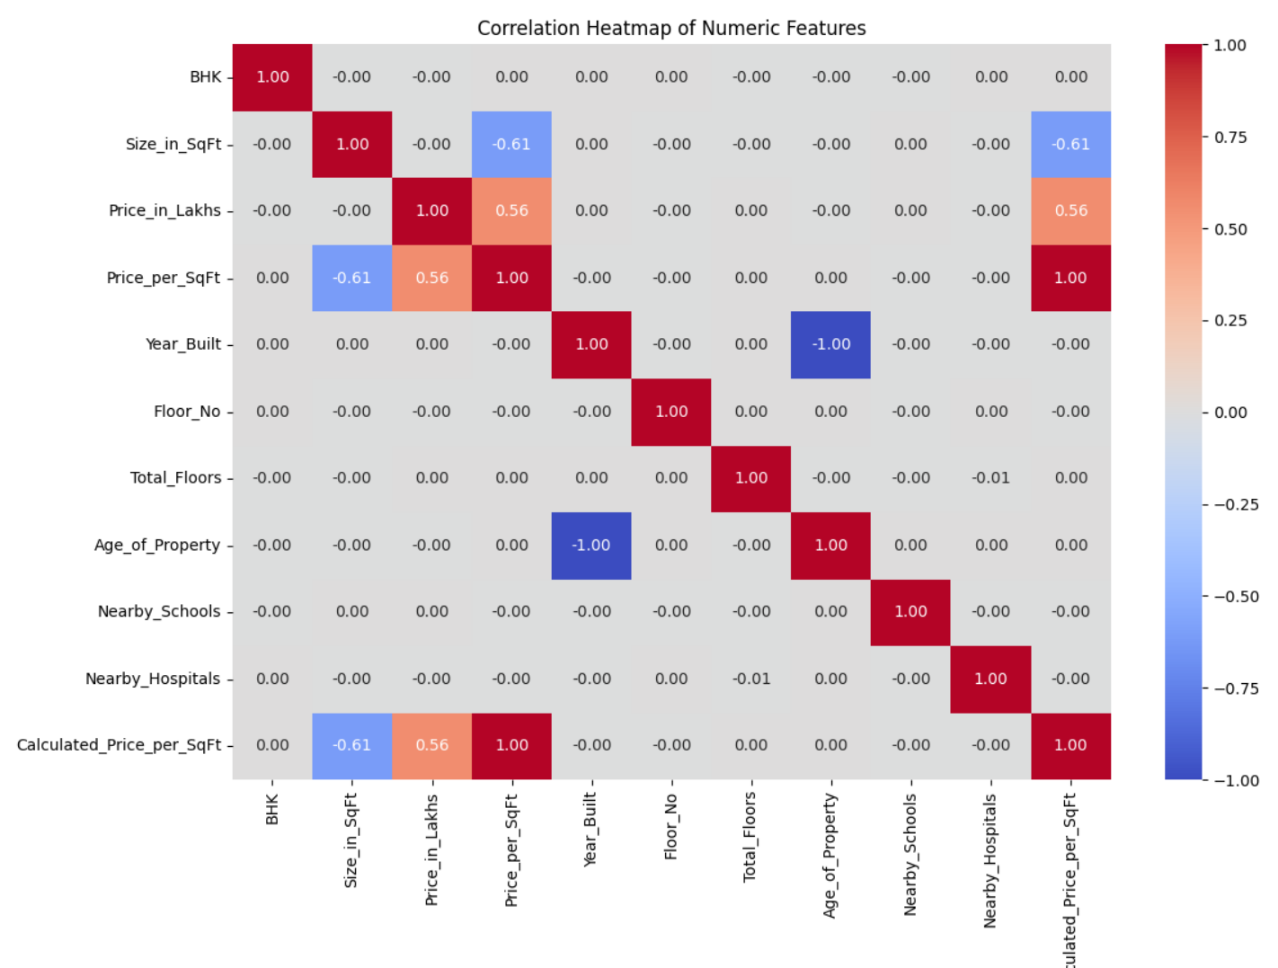
Figure 11. Correlation heatmap of numeric features

- How do nearby schools relate to price per square ft?
The number of nearby schools ranges from 1 to 10 in the dataset. The correlation between nearby-school count and recalculated price per square foot is approximately −0.0001, which is effectively zero. The price-per-square-foot bars are nearly the same height across the school-count categories. The median property-price chart is also fairly flat, with no clear pattern of prices rising as the school count increases.
Interpretation: These records show no meaningful linear association between the recorded number of nearby schools and either property price or price per square foot. The small differences between bars may reflect variation in the sample, rather than a consistent relationship. This does not prove that schools have no influence on property values in real markets.

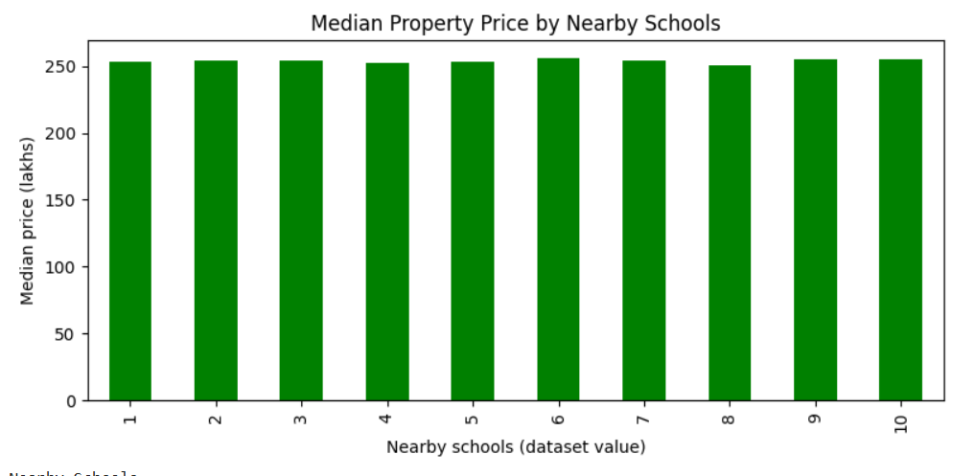
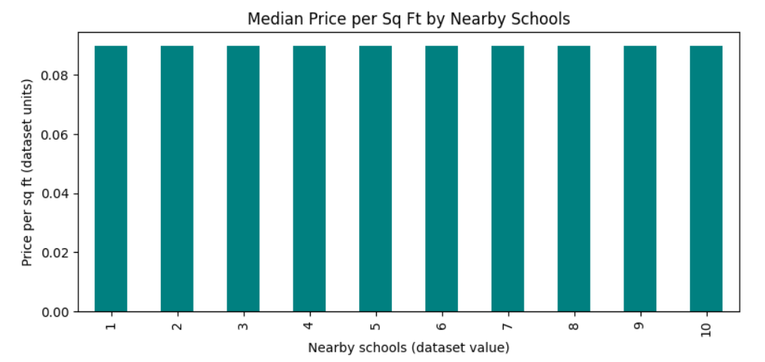
Figure 12. Median property price and median price per square foot by nearby-school count.

- How do nearby hospitals relate to price per square ft?
The dataset records nearby-hospital values from 1 to 10. The correlation between this feature and recalculated price per square foot is approximately −0.0001, which is effectively zero. The chart’s bars are almost equal in height across all hospital-count categories, with no consistent increase or decrease as the recorded count changes.
Interpretation: In this dataset, the number of nearby hospitals does not show a meaningful linear association with price per square foot. The small differences between categories are not enough to support a clear relationship, and they do not establish whether hospitals affect property prices in the real market.

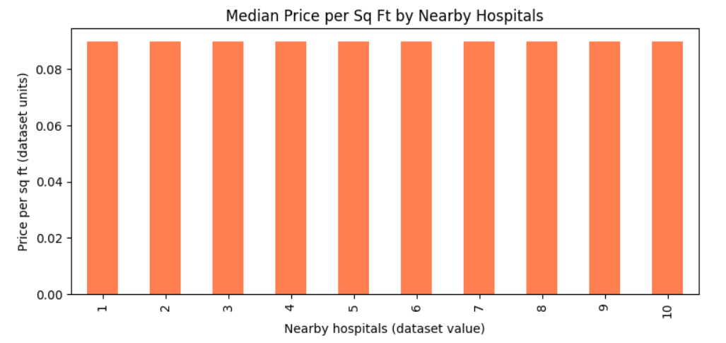
Figure 13. Median price per square foot by nearby-hospital count.
- How does price vary by furnished status?
Average property prices are very similar across the three furnishing categories: ₹254.45 lakhs for furnished properties, ₹254.34 lakhs for semi-furnished properties, and ₹254.98 lakhs for unfurnished properties. The difference between the highest and lowest averages is about ₹0.64 lakhs, a small gap relative to the prices themselves.
The chart shows median prices, which are also close: approximately ₹253.56 lakhs for furnished, ₹253.81 lakhs for semi-furnished, and ₹254.19 lakhs for unfurnished properties.
Interpretation: Neither the average values nor the medians show a substantial price difference by furnishing status in this dataset. The slightly higher average for unfurnished properties should not be interpreted as evidence that furnishing lowers prices; the chart shows descriptive comparisons, not cause and effect.

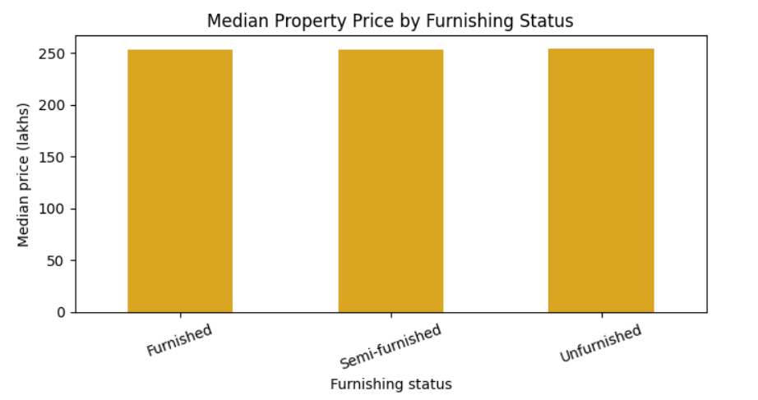
Figure 14. Median property price by furnishing status.
- How does price per square ft vary by property-facing direction?
Using the recalculated price per square foot in rupees, the average is approximately ₹13,024 for East, ₹13,025 for North, ₹13,044 for South, and ₹13,140 for West. West-facing properties have the highest average in this dataset, but the difference between directions is small.
Interpretation: Average price per square foot is broadly similar across all four facing directions. The modest difference for west-facing properties does not establish that direction causes a higher price.

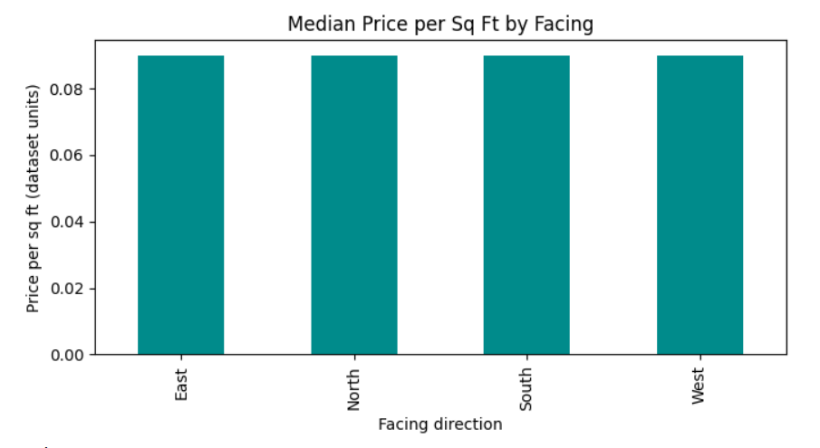
Figure 15. Median price per square foot by property-facing direction.

INVESTMENT /AMENITIES/OWNERSHIP ANALYSIS

- How many properties belong to each owner type?
The dataset contains 83,479 Broker-listed properties, 83,268 Owner-listed properties, and 83,253 Builder-listed properties. Each category accounts for about one-third of the 250,000 records. Broker listings are the largest group, but they exceed Builder listings by only 226 properties.
Interpretation: The owner types are almost evenly represented, so no category dominates the dataset. This balance makes it easier to compare the groups, but it may also reflect the unusually uniform structure observed elsewhere in the data.

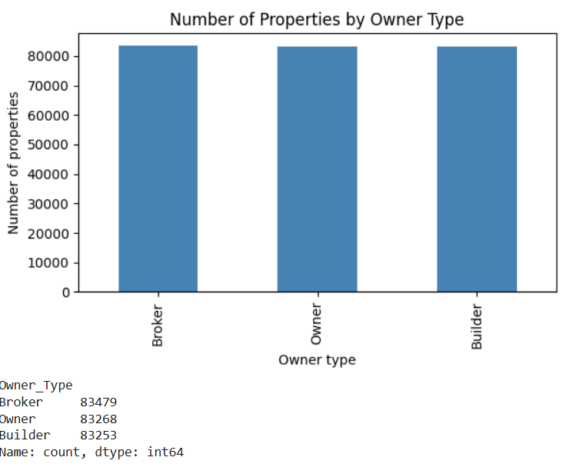
Figure 16. Number of properties by owner type
- How many properties are available under each availability status?
The dataset contains 125,035 Under Construction properties and 124,965 Ready to Move properties. These represent approximately 50.01% and 49.99% of the 250,000 records, respectively. The difference is only 70 properties.
Interpretation: The two availability categories are almost perfectly balanced, so neither status dominates the dataset. This balance supports straightforward comparisons between categories, but the near-equal counts also fit the unusually uniform pattern seen in other parts of the dataset. These counts describe the supplied data and may not reflect the actual proportion of property listings in the market.

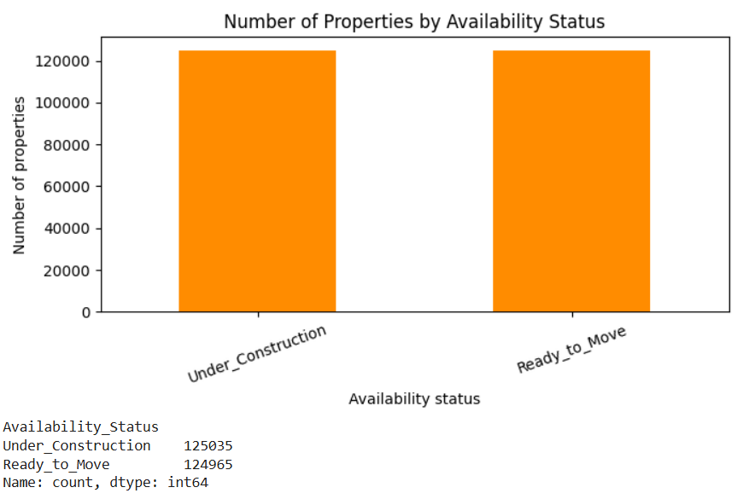
Figure 17. Number of properties by availability status.
- Does parking space affect property price?
The dataset records parking availability as Yes or No. The average property price is approximately ₹254.75 lakhs for properties with parking and ₹254.43 lakhs for properties without it—a difference of about ₹0.32 lakhs. The chart compares median prices: approximately ₹254.36 lakhs with parking and ₹253.37 lakhs without parking. Both measures show relatively small differences between the groups.
Interpretation: In this dataset, properties marked as having parking are priced slightly higher on average and at the median, but the gap is small compared with the typical property price. This descriptive comparison does not show that parking causes a higher price. The parking field is also recorded only as Yes/No, so it does not capture the number of spaces or their quality.

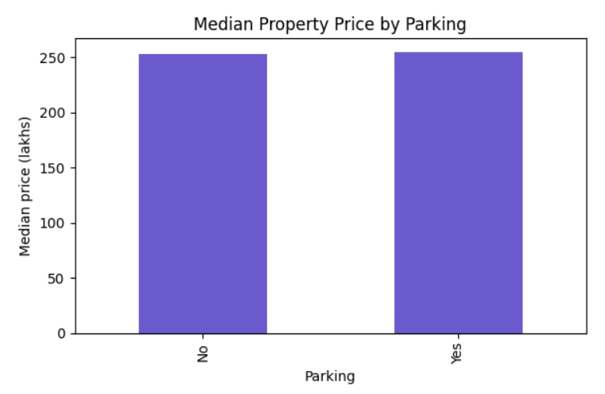
Figure 18. Median property price by parking availability.

- How do amenities affect price per square ft?
The chart compares the average recalculated price per square foot for properties that list each amenity with those that do not. A property was counted as having an amenity when that amenity appeared as an individual item in its comma-separated Amenities field. For example, a record listing “Gym, Garden” counts as having both a Gym and a Garden.
The averages are close across all five amenities. Properties listing a Gym average about ₹13,098 per sq ft, compared with ₹12,999 for those without one. The differences are also small for a Pool (₹13,073 vs. ₹13,037), Garden (₹13,065 vs. ₹13,049), Clubhouse (₹13,070 vs. ₹13,041), and Playground (₹13,049 vs. ₹13,072). The Playground comparison is slightly lower for properties listing it.
Interpretation: The chart shows no substantial difference in average price per square foot between the with-amenity and without-amenity groups in this dataset. The comparisons are descriptive and do not prove that an amenity raises or lowers property prices; other property characteristics may also differ between the groups.

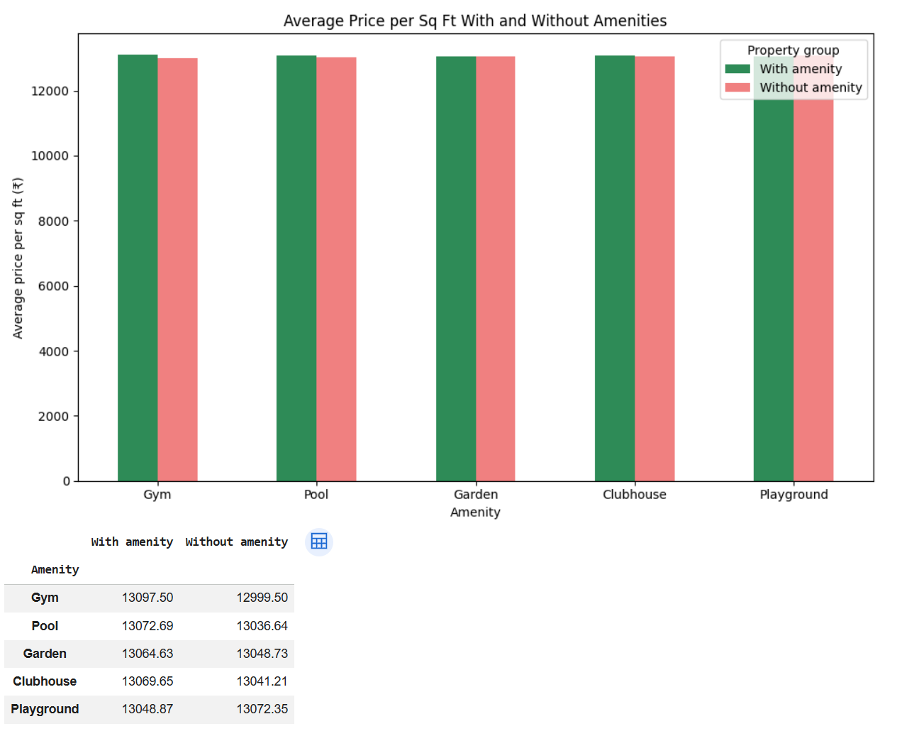
Figure 19. Average price per square foot for properties with and without selected amenities.

- How does public transport accessibility relate to price per square ft or investment potential?
Average recalculated price per square foot is approximately ₹13,027 for High, ₹13,062 for Medium, and ₹13,086 for Low public transport accessibility. The difference between the highest and lowest averages is about ₹59 per sq ft, less than 0.5% of the average values. The bars are therefore nearly the same height.
Using the project’s “Good Investment” rule, the proportion of properties labelled good is also similar across the categories: 50.2% for High, 49.9% for Low, and 49.9% for Medium accessibility.
Interpretation: Neither the average price per square foot nor the project-defined investment label varies substantially by the recorded transport-accessibility category. This does not establish that transport has no effect on real-world property values or investment returns; the label is a simplified price-per-square-foot rule, and the dataset has limitations.

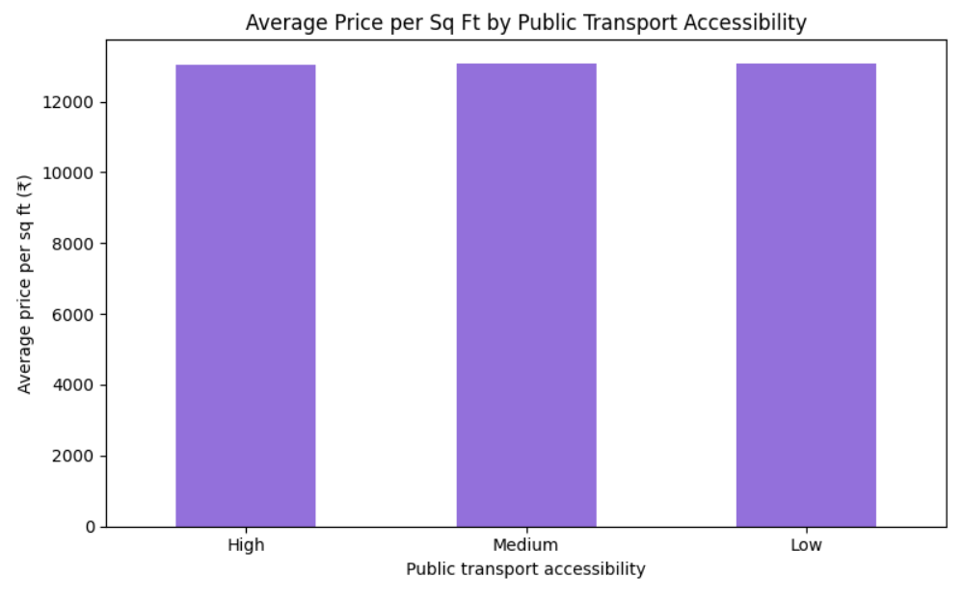
Figure 20. Average recalculated price per square foot by public transport accessibility.
RESULTS
1. Exploratory Data Analysis Results
Property prices ranged from ₹10 lakhs to ₹500 lakhs, with a mean of approximately ₹254.59 lakhs and a median of ₹253.87 lakhs. Property sizes ranged from 500 to 5,000 sq ft, with a median of 2,747 sq ft. Both distributions appeared unusually even across their ranges.
The scatter plot showed almost no linear relationship between property size and price: the correlation was approximately −0.003. This is unexpected in a typical property market and suggests caution when interpreting model findings.
The outlier analysis showed no size values beyond the IQR box-plot limits. Recalculated price per square foot, however, had many high-value outliers, with some values approaching ₹100,000 per sq ft. These records were identified as unusually high relative to the rest of the dataset and were not automatically removed.
Median price per square foot varied only modestly across property types: approximately ₹9,190 for villas, ₹9,245 for apartments, and ₹9,305 for independent houses. Average price per square foot across states also showed a relatively narrow range, from about ₹12,931 to ₹13,252.
Other category comparisons showed similarly small differences. For example, average property prices were approximately ₹254–₹255 lakhs across furnished, semi-furnished, and unfurnished properties. Properties marked as having parking averaged about ₹254.75 lakhs, compared with ₹254.43 lakhs for properties without parking. These comparisons do not establish that furnishing or parking causes a price difference.
The dataset contained nearly equal numbers of records across owner types, availability statuses, and BHK categories. Numeric correlations were generally close to zero, except where variables were mathematically related. For example, property age was calculated from year built, so those fields were perfectly inversely correlated.
2. Classification Results
Classification metric | Logistic Regression result
Accuracy | 0.712
Precision | Approximately 0.71
Recall | Approximately 0.71
F1 score | Approximately 0.71
A Logistic Regression baseline was evaluated using a 200,000-row training set and a 50,000-row test set. It achieved 71.2% accuracy. Precision, recall, and F1 score were each approximately 0.71 for both classes.

XGBoost was also trained for the project’s investment classification task. Its feature-importance chart is displayed in the Streamlit application. The chart indicates which features the trained model relied on most, but feature importance does not show that a feature causes higher property returns.
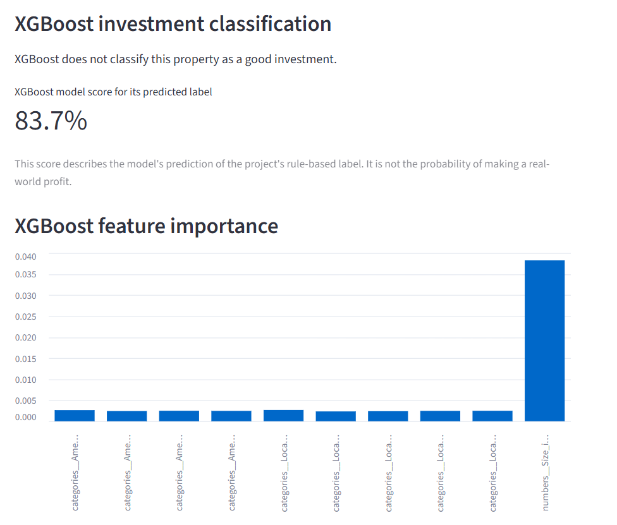
Fig 21: XGBoost feature importance
The “Good Investment” target was defined using a simplified rule based on price per square foot relative to the dataset median. Therefore, the classification results measure how well the model predicts that project-defined label; they do not measure actual investment profitability.
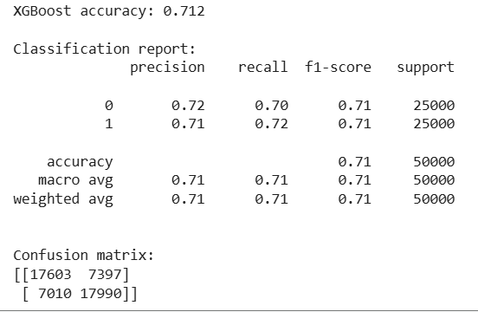
Fig 22: Classification report

3. Regression Results
The regression model achieved MAE = 0.00 lakhs, RMSE = 0.00 lakhs, and R² = 1.00 on the test data. These perfect scores occurred because the five-year price target was generated using the same assumed 8% annual increase that the model learned to reproduce. They do not demonstrate that the model can accurately forecast actual future market prices.
The Streamlit app displays this assumption as an illustrative five-year scenario. For example, a starting price of ₹100 lakhs grows to approximately ₹146.93 lakhs after five years under the 8% compounded-growth assumption.
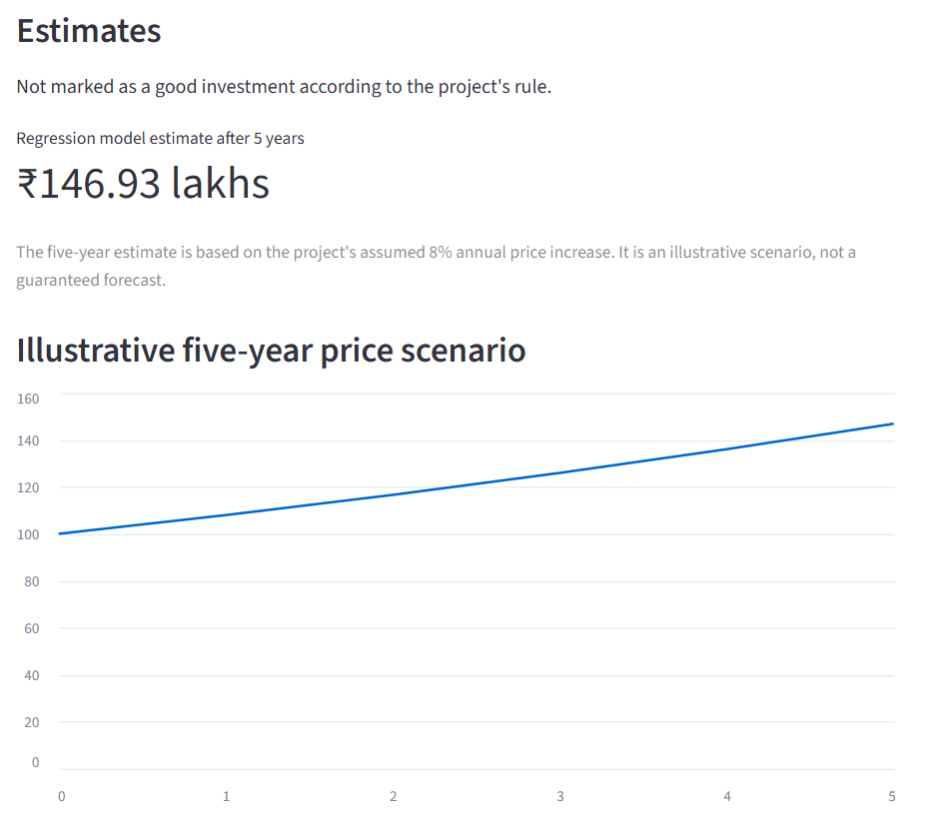
Fig 23: Illustration of five-year scenario
4. Streamlit Application Results
The deployed application lets a user enter property details and view the investment classification, the illustrative five-year price estimate, and visual summaries. It also includes an XGBoost feature-importance chart and a city-comparison chart.
The city-comparison bars are very similar in height. This reflects the relatively uniform prices in the dataset, so the chart should be presented as a summary of this dataset rather than evidence that one city is substantially more expensive than another.
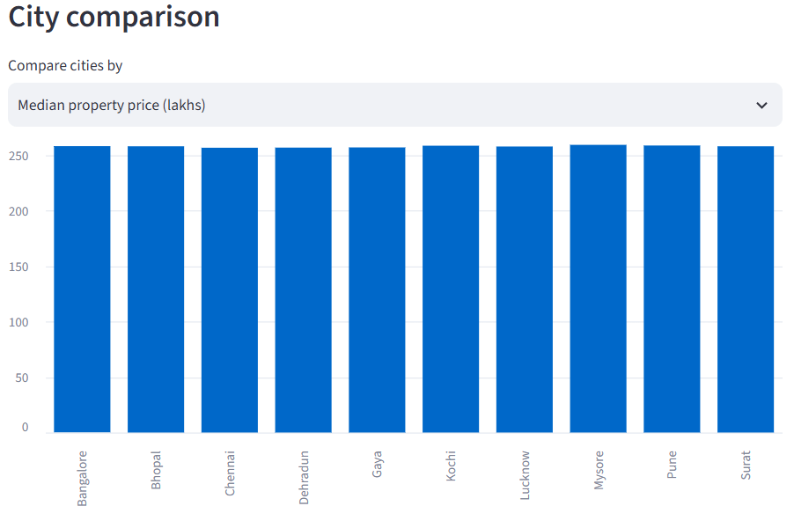
Fig 24: City comparison
- Overall Interpretation
The project demonstrates a complete analytics workflow: data inspection, EDA, classification, regression, MLflow experiment tracking, and presentation through a deployed Streamlit app. However, the unusually uniform price and size distributions, the near-zero size–price correlation, and inconsistent floor records limit how confidently the results can be generalized. The investment classification is based on a simplified project rule, and the future-price estimate depends on a fixed growth assumption. The application is therefore an educational demonstration, not verified financial advice or a reliable market forecast.
DISCUSSIONS
The analysis found that property prices and sizes were distributed unusually evenly across their ranges. Property prices ran from ₹10 lakhs to ₹500 lakhs, while sizes ranged from 500 to 5,000 sq ft. The correlation between size and price was approximately −0.003, showing almost no linear relationship in this dataset. Since property size would often be expected to relate to price, this finding raises questions about how realistically the data represents the housing market.
Differences between property categories and locations were also small. Median price per square foot was similar across apartments, villas, and independent houses, and average prices varied only modestly across states and cities. Furnishing status, parking, and public transport categories likewise showed little difference in average price. These results describe the supplied data; they should not be interpreted as evidence that these factors have no effect in real markets.
The outlier analysis showed no size values beyond the box-plot limits, but many high values for recalculated price per square foot. These unusually high ratios may result from properties with high prices relative to their sizes. They were identified for review rather than removed automatically, because the available data did not establish whether they were errors.
The Logistic Regression baseline achieved 71.2% test accuracy, with precision, recall, and F1 scores of about 0.71. This indicates moderate performance at predicting the project-defined investment label. However, the label was created from a simple price-per-square-foot rule, so the score shows how well the model learned that rule; it does not show how well it predicts actual profit. XGBoost provides an additional classification model, and its feature-importance chart helps summarize which encoded inputs the model relied on. Feature importance indicates model reliance, not cause and effect.
The regression model produced MAE and RMSE values of 0.00 lakhs and an R² of 1.00. These perfect results occurred because the five-year target was calculated using an assumed 8% annual increase. The model reproduced the formula used to create its target; it did not establish that property prices will actually increase at that rate. The five-year chart in the application should therefore be described as an illustrative scenario.
Overall, the project demonstrates data analysis, model training, experiment tracking, and deployment through Streamlit. Its findings are limited by the dataset’s uniform patterns, inconsistent floor records, and simplified target definitions. The app is useful as an educational demonstration of a real-estate analytics workflow, but its outputs should not be treated as verified investment recommendations or market forecasts.
LIMITATIONS OF THIS PROJECT
- Dataset realism: Prices and sizes appeared unusually uniform, and their correlation was approximately −0.003. This may limit how well the dataset represents real property markets.
- Inconsistent floor records: In 116,304 records, Floor_No exceeded Total_Floors. These records were flagged, but the correct values could not be confirmed or repaired.
- Simplified investment label: “Good Investment” was defined using a price-per-square-foot rule. It does not account for rental income, maintenance, taxes, financing, legal risks, or future market changes.
- Assumption-based regression target: The five-year price target was generated using an assumed 8% annual increase. The model’s perfect regression scores show that it reproduced this formula; they do not demonstrate accurate real-world forecasting.
- Limited predictive relationships: The size–price correlation was nearly zero, and several category comparisons showed only small differences. This limits the strength of conclusions the analysis can support.
- No historical price trends: The dataset does not provide a time series of past property prices. Therefore, actual price movements over time could not be analyzed.
- Feature-importance interpretation: XGBoost feature importance indicates which features the model used; it does not prove that those features cause price changes or investment returns.

CONCLUSION
This project developed a real estate analytics workflow using a dataset of 250,000 property records. It included data quality checks, exploratory analysis, classification and regression modeling, MLflow experiment tracking, and a deployed Streamlit application. The app lets users enter property details and view an investment classification, an illustrative five-year price scenario, and visualizations, including XGBoost feature importance.
The Logistic Regression baseline achieved 71.2% test accuracy for the project-defined investment label. The regression model reproduced its five-year target with MAE and RMSE of 0.00 lakhs and R² of 1.00 because that target was generated using an assumed 8% annual increase. This result demonstrates reproduction of the project formula, not reliable prediction of actual future prices.
Overall, the project demonstrates how data analysis and machine-learning tools can be combined in an interactive application. Its findings are limited by the dataset’s unusual distributions, inconsistent floor records, and simplified target definitions. The application should therefore be viewed as an educational demonstration rather than a source of verified investment or market advice.

FUTURE STUDY
Future work could improve this project by using verified property data with real historical prices, transaction dates, rental income, and market or economic indicators. This would allow analysis of actual price trends and support forecasting based on observed changes rather than a fixed 8% assumption.
The investment classification could also be expanded to consider factors such as rental yield, maintenance costs, taxes, financing, location growth, and legal status. Data quality checks could be strengthened, especially for inconsistent floor records and unusually high price-per-square-foot values. Model performance could then be compared across several algorithms using appropriate validation and evaluation metrics.
The Streamlit application could be enhanced with filters for city, locality, price, size, and BHK, along with clearer chart labels and explanations of model limitations. Finally, MLflow model registration and version tracking could be added to support managing and comparing finalized models.

